**Computer Applications Technology**

**Unlocking a resilient future**

corporate sector

**Riya Ramesh Patel**



**Shree bharat sharda mandir**

**Grade 12A**

Table of Contents

Table of figures 1

Introduction 2

Task Definition 2

Focus Question 3

Discussion and analysis 4

Findings 5

Conclusion 6

Bibliography 7

Appendices 8

Addendum 1 -Folder structure 8

Addendum 2- Source Table 9

Addendum 3 -Declaration 21

## Table of figures

Figure 1 Sources and questions table 11

# Introduction

# Task Definition

Since COVID-19 is a health crisis, employers must take responsibility for keeping their workforce safe and ensuring their people and customers aren't put at risk of infection. The lockdown regulations have a negative impact on the corporate sector, and many businesses were forced to close because they were unable to exit due to the regulations. Keeping people safe and healthy should be the objective for employers getting back to work during this health crisis, but companies will also be focusing on how they can maintain a productive, sustainable workforce that allows them to stay competitive with the use of technology. Organizations will have to adapt quickly to these developments, which in turn will put more pressure on supply chains to be responsive.

Some research needs to be conducted to analyse how the corporate sector is adapting by doing things differently. The focus of my PAT research will be on ICT in the corporate sector and other solutions in response to the COVID-19 pandemic. The investigation will be more focussed towards how the corporate sector used ICT by adapting to current situations such as the COVID-19 pandemic.

To complete the task I will be using an office suite, an HTML editor, Internet access, questionnaires, access to other sources, such as printed media (e.g. magazines, newspapers, brochures, textbooks) or other electronic material (e.g. e-books, e-articles), surveys and questionnaires.

The target audience of my task would be the corporate audience or the corporate employees which is referring to employees that work in big corporations and large enterprises to reduce the unemployment rate. Refers to the specific group of consumers most likely to want the product or service, and therefore, the group of people who should see ad campaigns.

# Focus Question

What improvements can be made in the corporate sector using solutions and tools that are ICT driven to mitigate the effects of Covid-19?

# Discussion and analysis

# Findings

# Conclusion

# Bibliography

# Appendices

## Addendum 1 -Folder structure

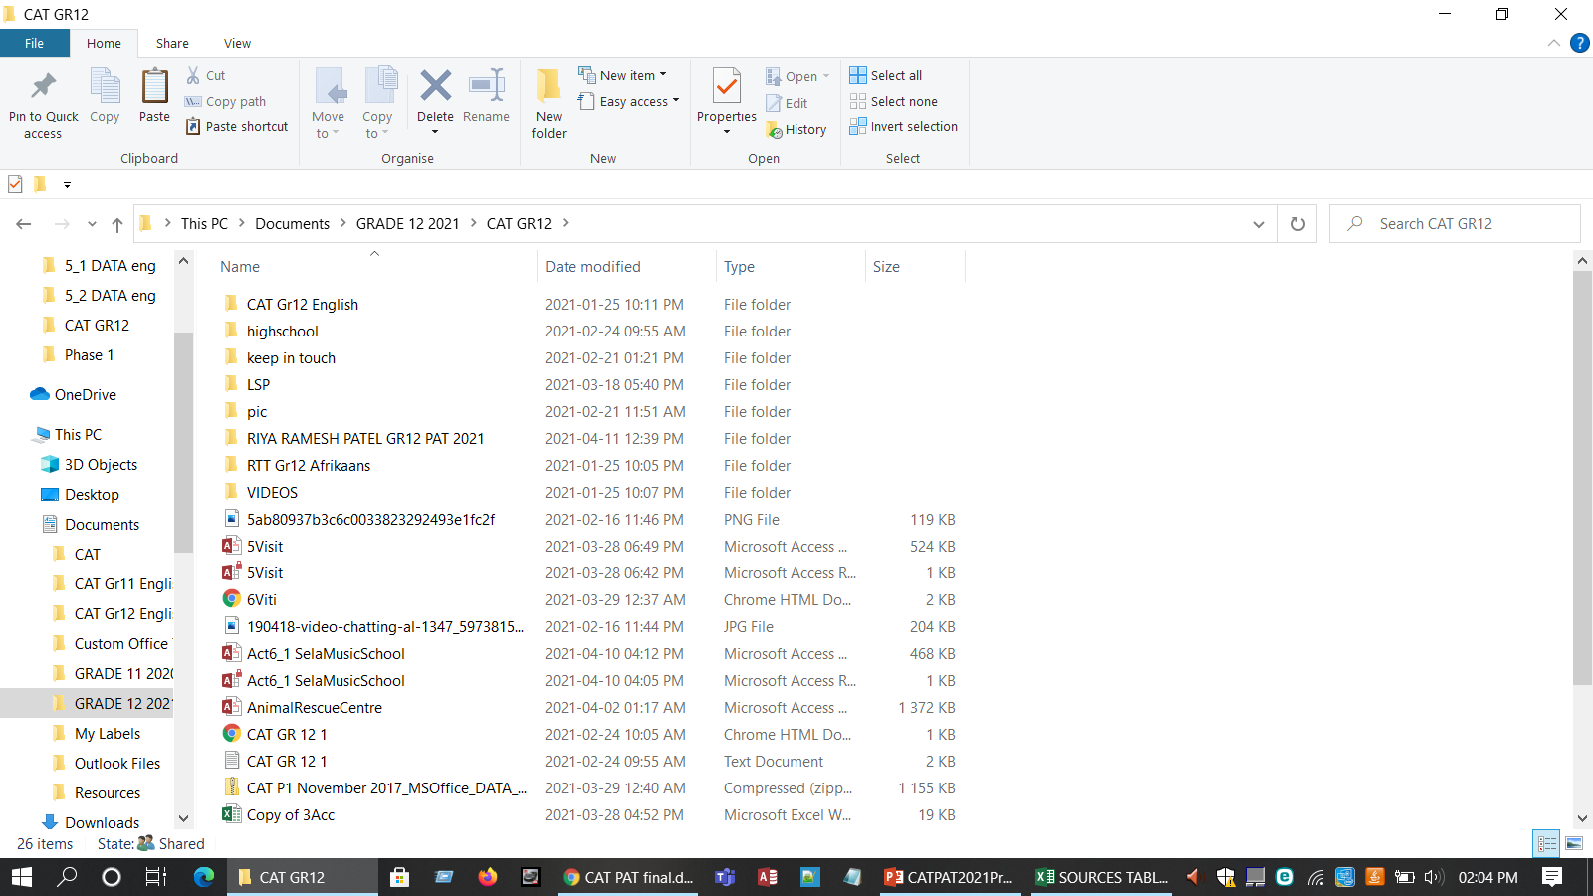

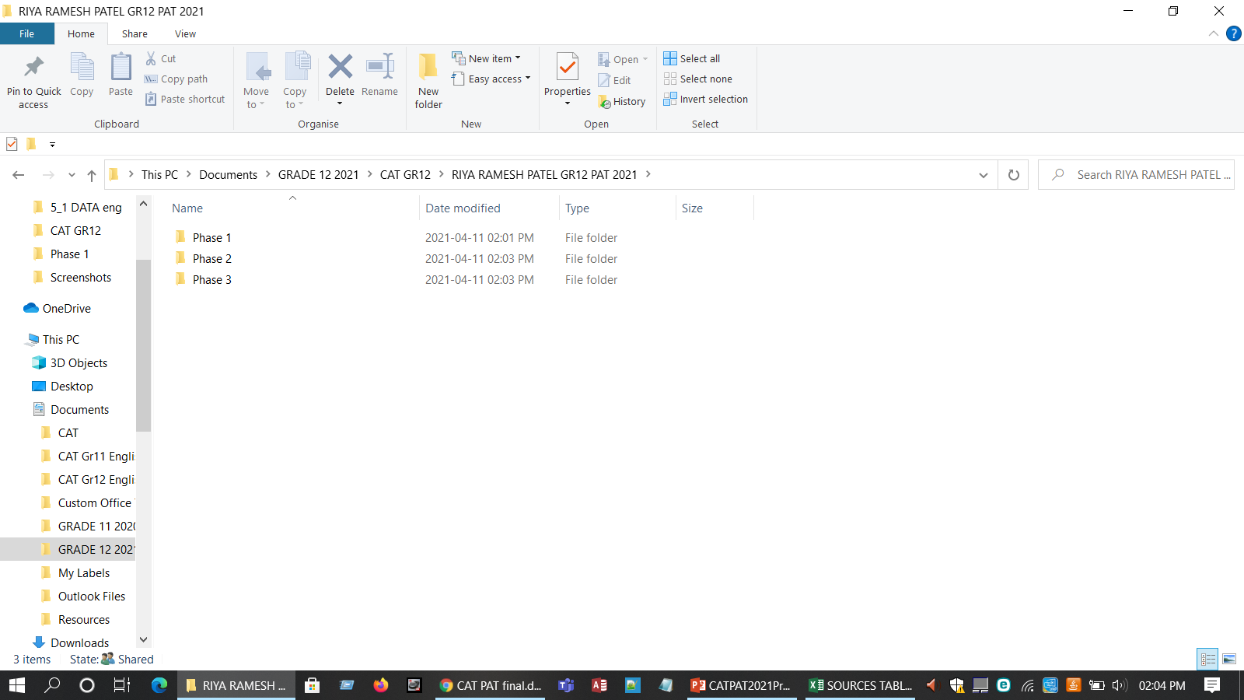

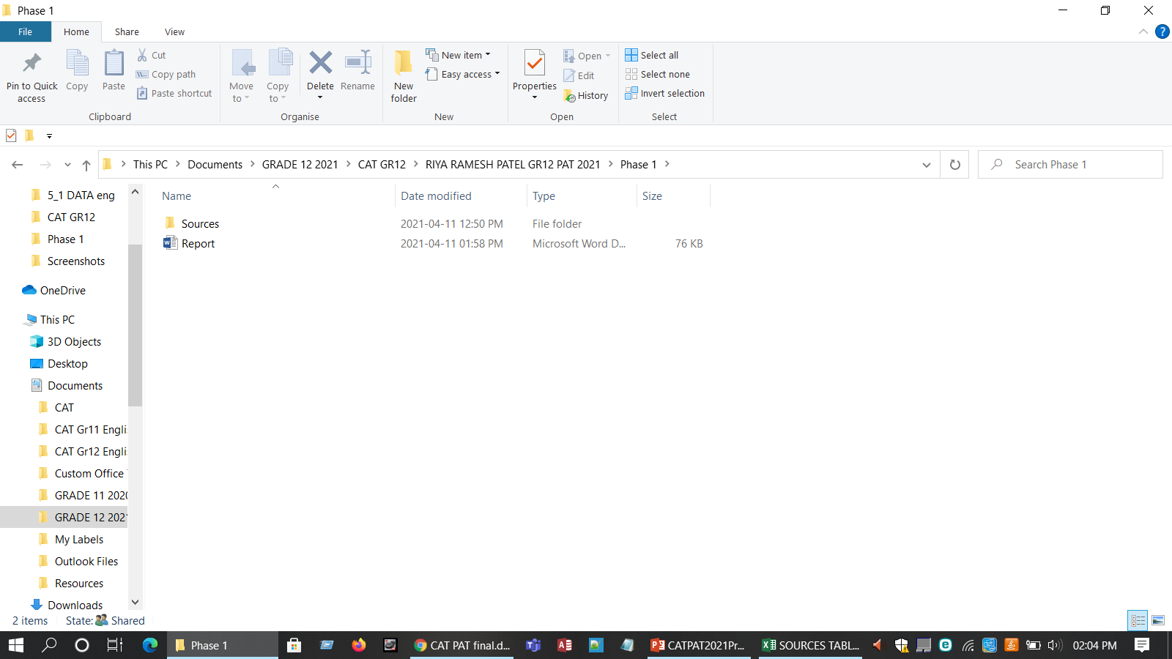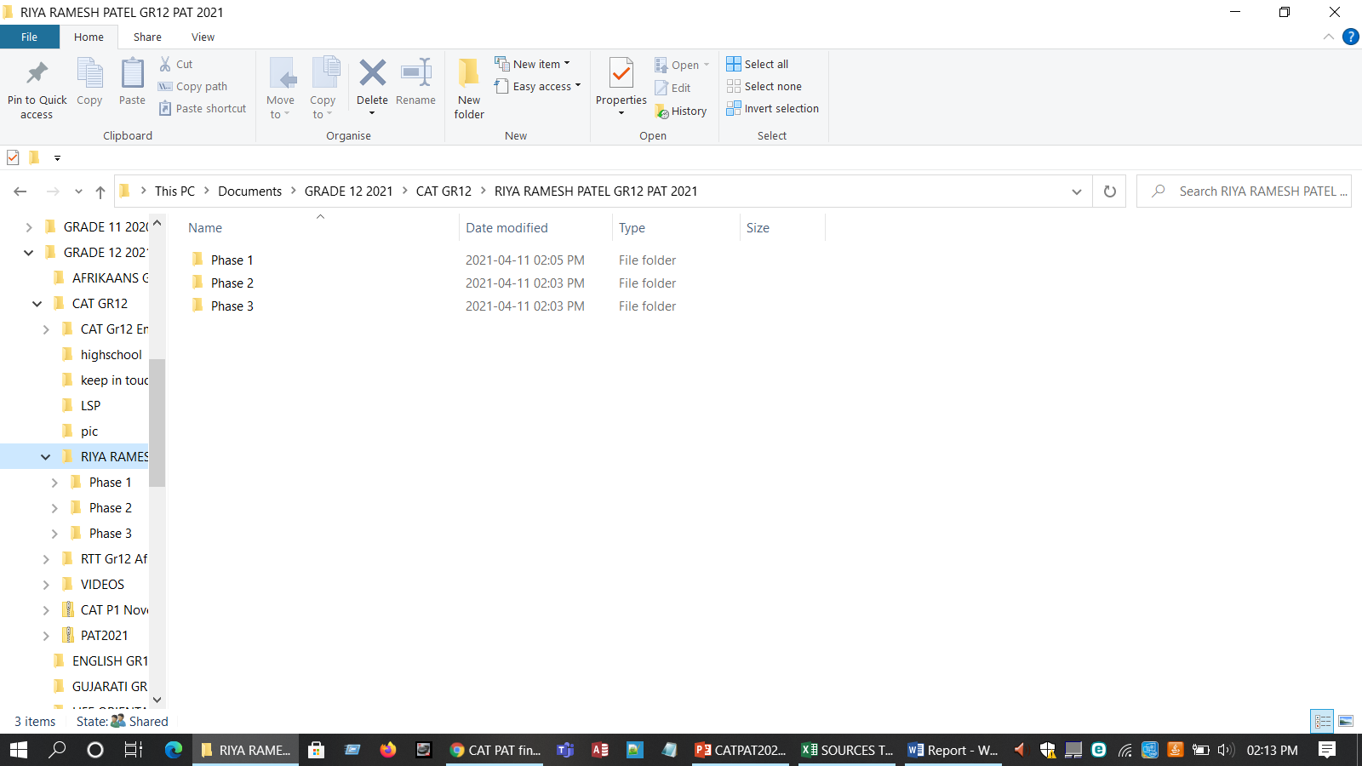

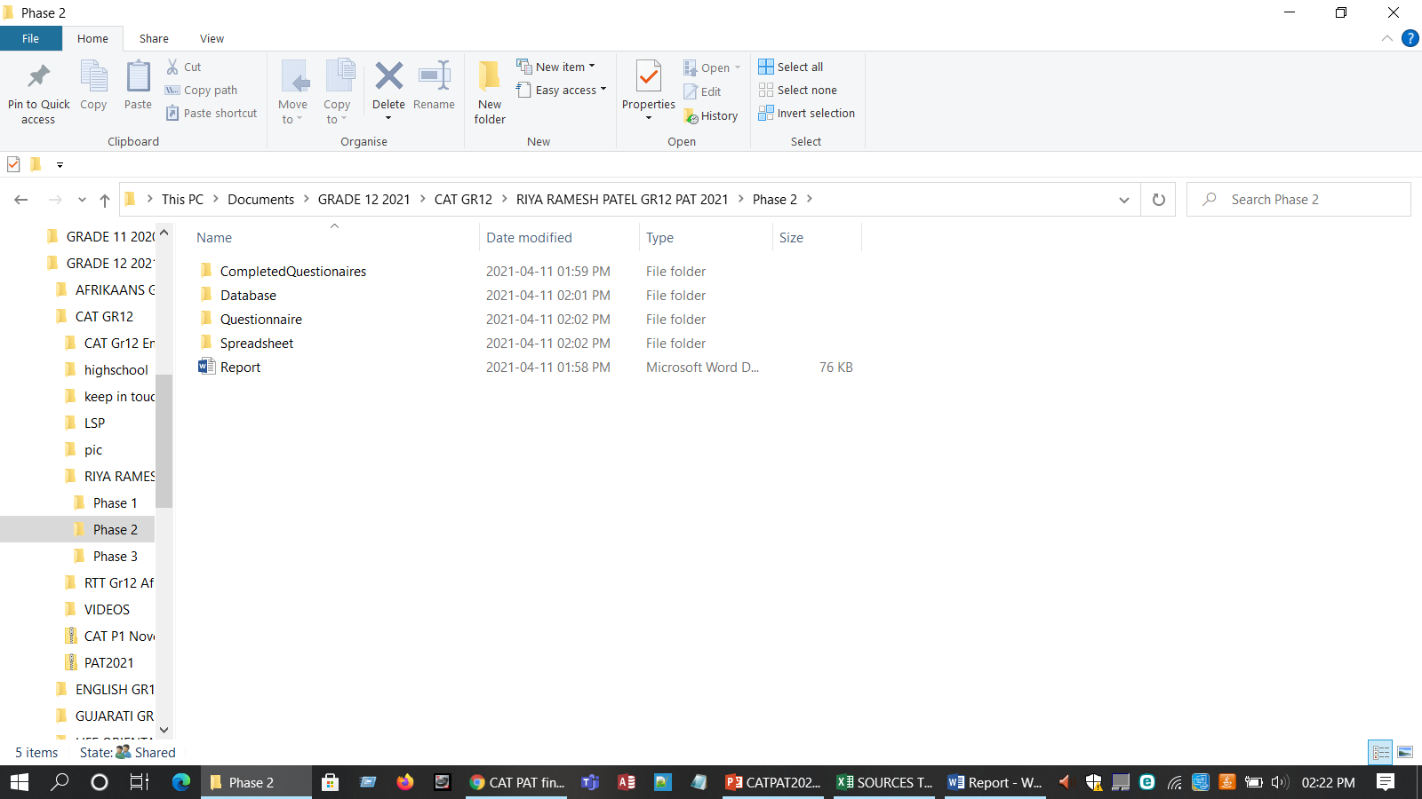

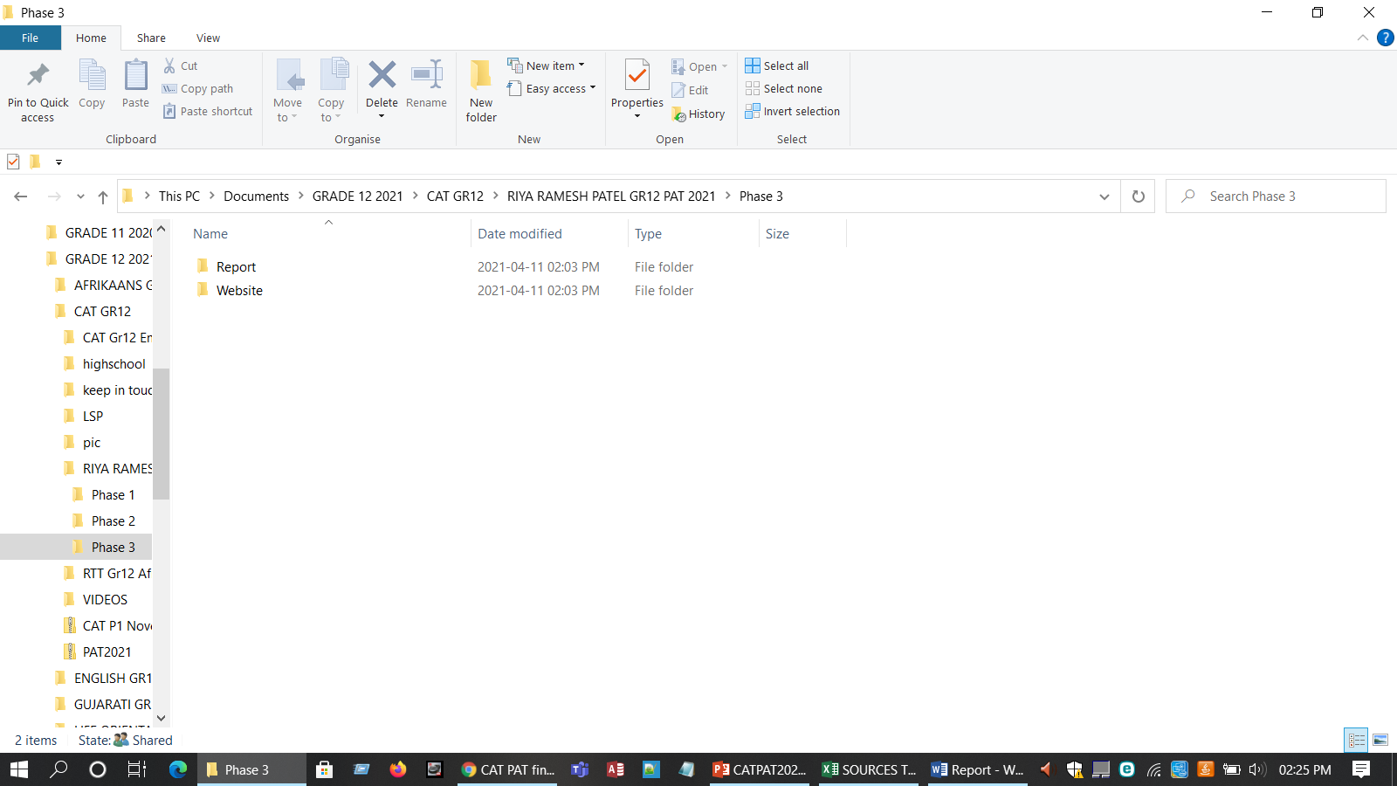

## Addendum 2- Source Table

|  |  |  |  |  |  |  |  |  |  |  |
| --- | --- | --- | --- | --- | --- | --- | --- | --- | --- | --- |
| **NO.** | **QUESTION** | **QUESTION LEVEL (1,2,3,4)** | | **CATEGORY** | **TYPE OF SOURCE** | **BIBLIOGRAPHICAL INFORMATION** | | **QUALITY OF INFORMATION FOUND** | | **SUMMARY OF INFORMATION FOUND** |
|
|  |  |
| **1** | In the event of a crisis, using ICT tools how can your company ensure the safety of its employees and the security of its productive assets? | 1 | | Impact | **Internet** | **Authors(s)** | EY Global | **Authority** | The author is from a Multidisciplinary professional services organization | Companies would need to define new working arrangements and reimagine business as normal while simultaneously adhering to local labour laws and prioritizing employee health and safety. |
| **Name of website/ web page** | Covid-19 pandemic and planning | **Currency** | This was published on the 19 of March 2020 |
| **Date created/updated** | 19-Mar-20 | **Accuracy** | The information provided corresponds with the current trends |
| **Date accessed** | 12-Apr-21 | **Objectivity** | The source is free of bias, and all of the information is accurate. |
| **URL** | https://www.ey.com/en_za/covid-19/covid-19-and-pandemic-planning--how-companies-should-respond | **Coverage** | The article goes into a lot of different systems. |
| **2** | How do you maintain safe cash flows and long-term financing on a electronic device ? | 2 | | Background | **Magazine** | **Author(s)** | Skye Schooley | **Authority** | The author assists in dealing financial problems in the business | You should always prioritize cash flow strategies in your business planning. Don't wait to send invoices. Adjust your inventory as needed. Re-evaluate your business operations. |
| **Title** | Business News Daily | **Currency** | This was published on the 23 of December 2020 |
| **Date published** | 23-Dec-20 | **Accuracy** | The data presented is consistent with current trends. |
| **Publisher** | Business news | **Objectivity** | There is no prejudice in the source and all the information is true |
|  |  | **Coverage** | The article covers a broad range of programs. |
| **3** | Are communication processes and procedures well-coordinated and structured to ensure consistent and open communication with all stakeholders? | 4 | | Solution | Website | **Authors** | Abudi, Gina | **Authority** | They plan for stakeholders in projects |  |
| **Name of website** | Managing communications effectively and efficiently | **Currency** | This was published on the 10 of April 2021 | Improving the effectiveness of communications overall, including frequency and quality. |
| **Date created** | 09-Aug-13 | **Accuracy** | The information provided corresponds with the current trends | Keeping individuals engaged in the initiative through open communications. |
| **Date accessed** | 10-Apr-21 | **Objectivity** | The source is free of bias, and all of the information is accurate. | Getting stakeholders involved in communications through enabling for more effective two-way conversations. |
| **URL** | https://www.pmi.org/learning/library/managing-communications-effectively-efficiently-5916 | Coverage | The article goes into a lot of different services that are available. |  |
| **4** | Does the company have crisis management teams in place to deal with short-term liquidity issues and implement effective countermeasures using technology? | 3 | | Background | Website | **Author(s)** | Dorothée ALLAIN-DUPRÉ | Authority | Author is from the OECD Centre on SMEs, Entrepreneurship, Regions and Cities |  |
| **Name of website** | OECD | Currency | This was published on the 10 f November 2020 |
| **Date created** | 10-Nov-20 | Accuracy | The data presented is consistent with current trends. | Assessing the likelihood of a particular crisis occurring - and its possible frequency. |
| **Date accessed** | 13-Apr-21 | Objectivity | There is no prejudice in the source and all the information is true | Determining its possible impact on your operations. |
| **URL** | https://www.oecd.org/coronavirus/policy-responses/the-territorial-impact-of-covid-19-managing-the-crisis-across-levels-of-government-d3e314e1/ | Coverage | The article goes into a lot of different systems. |  |
| **5** | In the event of a crisis, what mode of technology do you use to assess possible threats and determine responses? | 3 | | Impact | Book | **Author(s)** | Tobie Wiese | Authority | Author addresses the changes in the corporate governance landscape in South Africa |  |
| **Title of source** | Corporate governance in South Africa- book | Currency | This was published on the 26 of February 2017 | ABCD Crisis Intervention. |
| **Date published** | 26-Feb-17 | Accuracy | The information provided corresponds with the current trends | Critical Incident **Stress** Management (CISM) |
| **Publisher** | Juta and Co | Objectivity | There is no prejudice in the source and all the information is true | NOVA Crisis Intervention. |
|  |  | Coverage | The article covers a broad range of programs. |  |
| **6** | Have you factored in the effects of a crisis in digital budgeting and business planning processes, as well as incorporated early warning systems? | 4 | | Costs | Website | **Author(s)** | Jady Carlan | Authority | She is a well-known business manager | Treating a budgeting process. The benefits. What’s the annual plan? Using the budget to measure performance |
| **Name of website** | Info entrepreneurs | Currency | This was published on the 26 of February 2017 | Identify potential crises that might affect you |
| **Date created** | 11-Jan-20 | Accuracy | The data presented is consistent with current trends. | Determine how you intend to minimise the risks of these disasters occurring |
| **Date accessed** | 11-Apr-21 | Objectivity | There is no prejudice in the source and all the information is true | Set out how you'll react if a disaster occurs in a business continuity plan |
| **URL** | https://www.infoentrepreneurs.org/en/guides/budgeting-and-business-planning/ | Coverage | The article goes into a lot of different services that are available. | Test the plan regularly |
| **7** | How do you change your business using technology models to minimize costs in the short and medium term when a crisis has a major financial impact? | 3 | | Costs | Website | **Author(s)** | Melanie Butler | Authority | She is a forensic accountant by background, she leads PwC’s Global Crisis Centre. She led the firm’s response to the 2013–16 Ebola outbreak in West Africa. | Evaluate the supply chain. Get communication right. Use scenario analysis. Don’t lose sight of other risks. |
| **Name of website** | Strategy+Business | Currency | This was published on the 6 of March 2020 |
| **Date created** | 06-Mar-20 | Accuracy | The information provided corresponds with the current trends |
| **Date accessed** | 12-Apr-21 | Objectivity | The source is free of bias, and all of the information is accurate. |
| **URL** | https://www.strategy-business.com/blog/Seven-key-actions-business-can-take-to-mitigate-the-effects-of-COVID-19?gko=4c0d1 | Coverage | The article goes into a lot of different systems. |
| **8** | How will demand disruption affect the rate of the data stored on computers? | 2 | | Impact | Article | **Author(s)** | Michael Gattone | Authority | He is a well know planner in the business | Invest in protective gear for supply-chain workers and communicate via apps to manage time, availability and safety. Work closely with existing suppliers while diversifying the supply base |
| **Title of source** | Coronavirus and Supply Chain Disruption: What Firms Can Learn | Currency | This was published on the 17 of March 2020 |
| **Date published** | 17-Mar-20 | Accuracy | The data presented is consistent with current trends. |
| **Publisher** | Business Daily | Objectivity | There is no prejudice in the source and all the information is true |
|  |  | Converge | The article covers a broad range of programs. |
| **9** | With what methods of technology can be used to identify the supply chain and development risks that a crisis could bring? | 3 | | Impact | Article | **Authors** | Numra Moosa | Authority | She works in a supply development country |  |
| **Title** | Info entrepreneurs | Currency | This was published in 2017 | Improve your cyber supply chain risk management. |
| **Date published** | 2017 | Accuracy | The information provided corresponds with the current trends | Important for organizations to mitigate, manage, and handle risk in their supply chain if they want to ensure customer satisfaction, experience greater profitability and outcompete competitors. |
| **Publisher** | Kindle edition | Objectivity | There is no prejudice in the source and all the information is true | Manage environmental risk in your supply chain. |
|  |  | Coverage | The article covers a broad range of programs. |  |
| **10** | Is your business model stable enough to rebound from the effects of a recession and deal with future crises with regards to technology? | 3 | | Solution | Magazine | Author(s) | John Qeulch , Katherine Jocz | Authority | The author assists in helping others to deal with problems in the future |  |
| Title of source | How to market in downturn | Currency | This was published on the 5 of April 2020 | Identify ways to capitalize on the downturn in the longer term, partly by exploiting the mistakes of less savvy rivals. |
| Date published | 05-Apr-20 | Accuracy | The data presented is consistent with current trends. | customers priority, marketing strategy ,developing innovative practices |
| Publisher | Business review | Objectivity | The source is free of bias, and all of the information is accurate. |  |
|  |  | Coverage | The article goes into a lot of different services that are available. |

Figure 1 Sources and questions table

## Addendum 3 -Declaration

|  |  |  |  |  |
| --- | --- | --- | --- | --- |
| **Learner name** | Riya Ramesh Patel | | **ID Number** | 1103041139526 |
| **Grade** | 12 A | | **Year** | 2021 |
| **Subject** | Computer Applications Technology | | | |
| Practical Assessment Task (PAT) | | | **Teacher** | Ms. Kimara Thavar |
| Did you receive any help/information from anyone to complete this project?  √No Yes (provide details below) | | | | |
| Help/Information received from (person): | | Nature of the help/information (provide evidence): | | |
|  | |  | | |
| I hereby declare that the contents of this assessment task are my own original work (except where there is clear acknowledgement and appropriate reference to the work of others) and that I have not plagiarized, copied from someone else or used work previously submitted for assessment by anyone.    _________________________ 13/ 04/ 2021  SIGNATURE OF LEARNER DATE | | | | |